Instalare proiect

1. Git: https://github.com/madalin93cc/SmartFeedback.git
2. Gradle:
   1. Download: <https://services.gradle.org/distributions/gradle-2.7-bin.zip>
   2. Setare variabila de mediu GRADLE_HOME la %unde_ai_dezarhivat %
   3. Adaugare in path %GRADLE_HOME%\bin
3. Tomcat:
   1. Download: <http://apache.javapipe.com/tomcat/tomcat-8/v8.0.28/bin/apache-tomcat-8.0.28-windows-x64.zip>
   2. Setare variabila de mediu CATALINA_HOME la %unde_ai_dezarhivat %
   3. Adaugare in path %CATALINA_HOME%\bin
4. Instalare nodeJs:
   1. Download: <https://nodejs.org/en/download/>
5. Se deschide un terminal in root-ul proiectului; acolo unde e fisierul bower.json
6. se da comanda: npm install –g bower
7. se da comanda: bower install
8. Intellij Idea:
   1. Download: <https://www.jetbrains.com/idea/download/>
   2. File -> New -> Project from Existing Sources -> import project from external model -> selecare Gradle -> next - > si astepti
   3. Run -> Edit Configuration -> + -> Application

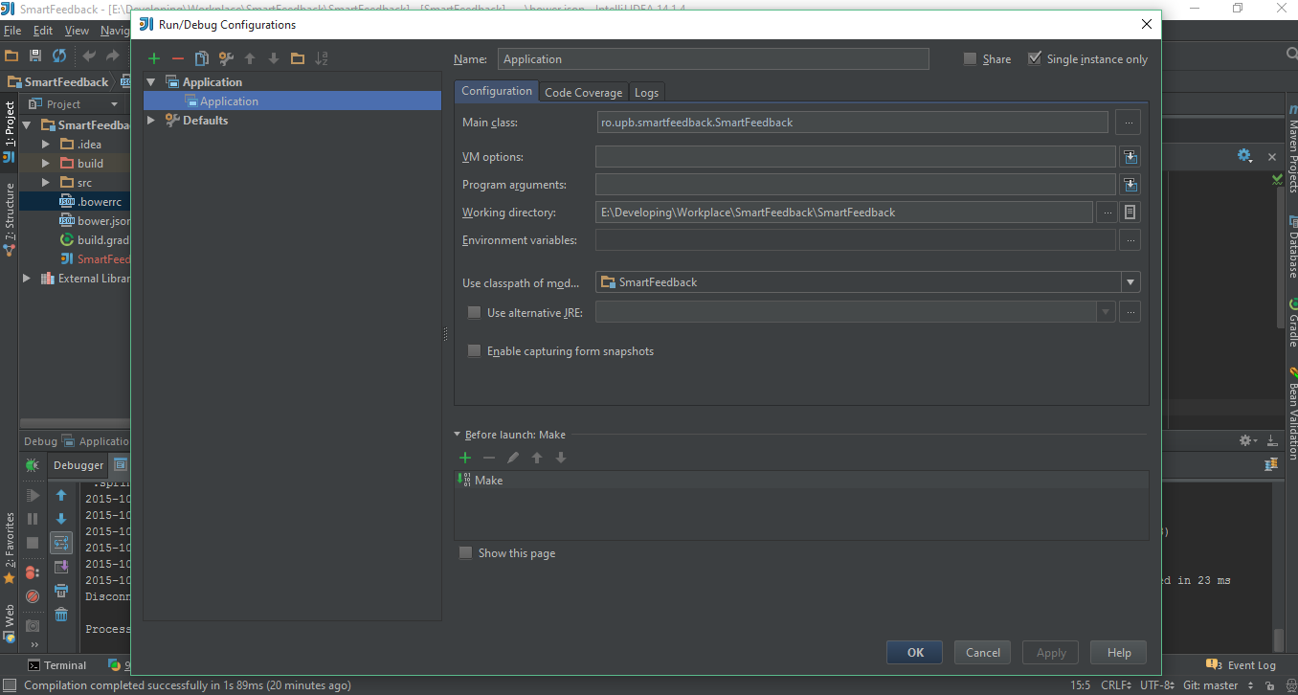

* 1. Se porneste de pe gargarita ;)